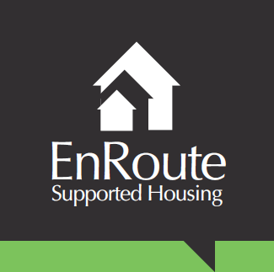
CSE Practitioner Job Description

Job summary and purpose

We are seeking a CSE Practitioner to work across our CSE service range and be responsible for developing safe, professional, supportive and nurturing relationships with the young people. You will be required to compile assessments, implement individual interventions, whilst supporting young people to recognise risk and develop resilience using approved therapeutic methods.
You will have experience in working with vulnerable clients, deal effectively with challenging situations and behaviour and build sustained relationships to engage young people. You must have a sound understanding of the safeguarding legal framework for young people and be confident in lone working situations.

Overall aims
- To develop positive and supportive relationships with young people.
- To reduce the risk of CSE for young people.
- To support young people to achieve the best outcomes for themselves.

Duties
- To provide a range of services to young people in Norfolk who are running away from home or care and are vulnerable to, or victims of child sexual exploitation.
- To provide targeted support, befriending and return home interviews for our Rose Project.
- To deliver support work sessions within our therapeutic supported accommodation EnRoute Project.
- To form effective relationships with young people and to ensure that a caring environment is maintained, and that the emotional and physical needs of young people are met within the EnRoute Project.
- To contribute to young people’s care plans, their review and implementation and to maintain good quality records to ensure all young people are provided with a high-quality person-centred service and attend LAC reviews and other meetings as required.
- To support young people to increase their knowledge of child sexual exploitation, healthy relationships, grooming, sexual health, sexting and online safety.
- To assess and mitigate risk and work with the staff team to ensure risk assessments for the young people and the house are complete and up to date.
- Play an integral role in contributing and sharing information at Multi Agency Sexual Exploitation (MASE) Meetings and other professional meetings for individual young people as and when appropriate.
- To gain young people’s views on the design and delivery of the service and work towards ways of implementing their ideas.
- To encourage young people to engage with and if necessary accompany them to meetings and appointments with professionals and other organisations including Job Centre, Doctors and sexual health clinics.
- Liaise with partner agencies to share information and intelligence for the safeguarding of children and young people.
- To support young people to access opportunities such as education, training, volunteering, work experience and employment.
- To follow all legislation requirements and policies within the home.
- To develop and maintain working relationships with young people, their families, social workers, housing associations and other professionals.
- To work with the staff team to ensure all Health and Safety and safeguarding practices are maintained so that the house is a safe environment for young people, staff and visitors to the home.
- Contributing to the preparation of information based resources including leaflets and our websites.
- Contribute to the development of Policies and Procedures in relation to operational area and The Magdalene Group as a whole.
- To undertake other duties as required by the Team Manager or other senior member of staff.

Accountable to: Team Manager.

Based at: The Magdalene Group, 61 King Street, Norwich, NR1 1PH, and the supported accommodation project in North Norfolk.

Hours of work: 37.5 hours per week, including some evening, weekend and bank holiday working. We would request a commitment to a minimum of one sleep-in per week, with further sleep-ins in response to client need.

Salary: £18,000 - £23,000 FTE.

Other Requirements
- Due to the nature of the role it is a General Occupational Requirement that this position be filled by a female. (Equality Act 2010.)
- Enhanced clearance by the Disclosure and Barring Service for children and vulnerable adults.
- Undertake all relevant training appropriate to the role.
- Full clean UK driving licence.

