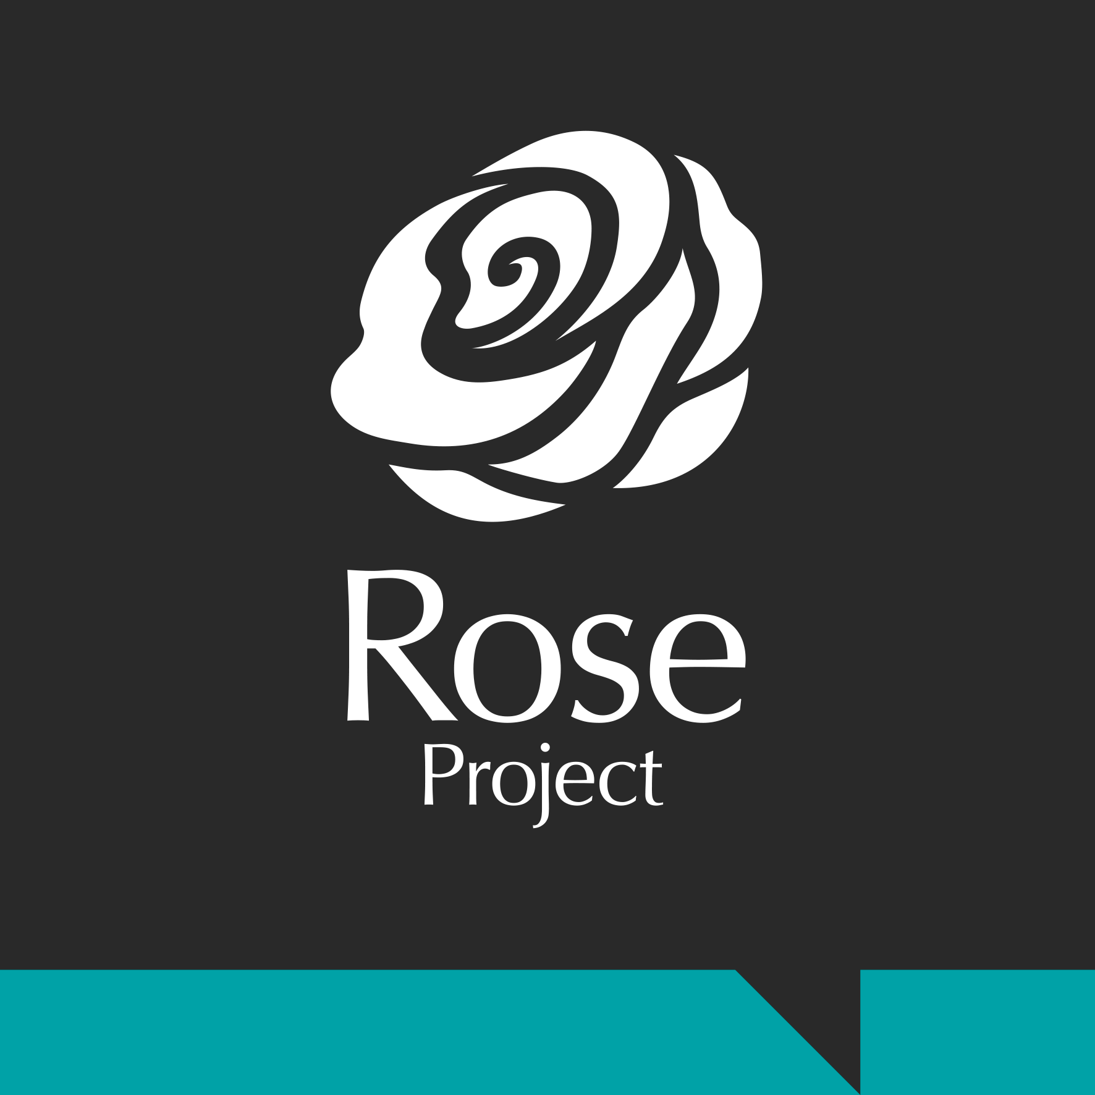
The Magdalene Group
Job Description

Young People’s Outreach Worker

Job summary and purpose

The post-holder will be based within the Young People’s Service. The purpose of this specialist role is to engage with and provide appropriate emotional and practical support to young people experiencing, or at risk of, sexual exploitation. The post-holder will work intensively with vulnerable young people in a trauma-informed way to safe-guard them and reduce risk of further exploitation. The post-holder will work within a multi-agency approach ensuring that at the heart of their safeguarding practice is a recognition of the young person’s voice.

Principal Responsibilities:

- Design an outreach programme to engage with vulnerable young people ensuring they have access to CSE services.
- Identify need and carry out outreach on a weekly basis in known hotspots of concern with the aim of engaging young people, providing services in the community and where determined by the young people.
- Ensure that safe-guarding practice is embedded within working practices to effectively support young people experiencing, or at risk of, sexual exploitation.
- Build positive relationships with identified young people and through intensive 1:1 support empower them to understand exploitation.
- Support young people to access and engage with specialist support services such as housing, healthcare, substance-misuse, through an holistic and solution-focused approach.
- Ensure the young person feels a partner in any multi-agency and co-ordinated support.
- Regularly assess and review the intervention and the required level of support for individual young people.
- Establish, develop and maintain good relationships with partner agencies, professionals and organisations, both statutory and voluntary.
- Build an evidence-base of qualitative and quantitative data to be shared with key partners and agencies and to influence future strategies.
- In conjunction with the staff team, represent the organisation at events to disseminate findings and evidence-base.
- Undertake the administrative tasks associated with providing support services including gathering statistical information, communicating with team members and maintaining office systems.

- Contribute to the preparation of information-based resources, including leaflets and our website.
- Work with the staff team to undertake monitoring and evaluation of the service including the writing of reports.
- Contribute to the development of policies and procedures in relation to operational area and The Magdalene Group as a whole.
- To undertake other duties as required by the CEO.

Accountable to: Young People’s Services Manager

Based at: Office base, 61 King Street, NR1 1PH, other organisational premises, and Outreach Work in Norfolk.

Hours of work: 37.5 hours including evening, early morning and some weekend work.

Annual leave: 26 days plus Bank Holidays.

Salary: £20,860 FTE

Other Requirements:

- Due to the nature of the role, it is a General Occupational Requirement that this position be filled by a female. (This role is exempt under the Equality Act 2010 Schedule 9, Part 1.)
- Enhanced clearance by the Disclosure and Barring Service, for children and vulnerable adults.
- Undertake all mandatory training provided by The Magdalene Group.
- Full UK Driving Licence, business insurance, breakdown cover.

