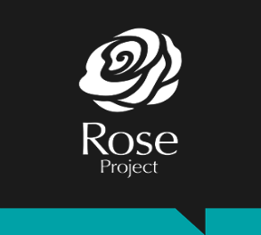

Young People’s Child Sexual Exploitation (CSE) Practitioner (Rose Project)
Person Specification

Criteria | Must be able to demonstrate
Skills and Knowledge
- An in-depth understanding of issues that affect children and young people, including those who are reported missing, those who have been sexually exploited and those involved in criminal exploitation.
- Excellent inter-personal skills with the ability to establish and maintain trusted relationships with children and young people.
- An understanding of the impact of trauma and of working within a trauma-informed approach to deliver interventions with children and young people experiencing CSE.
- Knowledge and understanding of current legislation related to child safeguarding and child exploitation.
- Ability to work autonomously and as part of a team.
- Ability to be adaptable, flexible and have the emotional resilience to deal with challenging situations, changing priorities and demands.
- Ability to organise and manage a high workload and to work with case-management procedures.
- Ability to plan and lead group sessions with children and young people, face-to-face and using online platforms.
- Excellent assessment skills and ability to communicate assessment of need and risk to children and young people and other professionals/parents/carers in person and in writing.
- Ability to produce reports for trustees, funders and management.
- Strong administration, IT and digital media skills including Microsoft Word, Excel and Outlook.

Education, Experience and Achievements
- A degree in a relevant field or demonstrable experience of working with children and young people who have experienced exploitation .
- Knowledge of child sexual exploitation (CSE) legislation and policy.
- Have experience engaging, listening, sharing and using children/young people’s views to shape services that they receive and change practice.
- Have substantial experience of multi-agency working/partnership working.
- Experience of identifying and carrying out risk and needs assessments.
- Experience of planning, delivering and reviewing interventions with children and young people.
- Experience of providing support and advocacy while ensuring choice, collaboration, transparency and safety.
- Ability to identify safeguarding concerns and take appropriate action to ensure children and vulnerable adults are protected.
- Experience of working in partnership with a wide range of agencies both statutory and voluntary and using professional challenge to advocate for the needs of children and young people.
- Confidence or experience working with digital media technology.
Personal Attributes
- Ability to establish and maintain clear boundaries in respect of personal and professional responsibility.
- Confident, adaptable and flexible approach.
- High level of accuracy, attention to detail and ability to maintain records throughout all services.
- Commitment to equality and diversity throughout all service delivery.
- Passionate about working with and listening to children and young people.
Special Circumstances
 | - An interest in the ongoing development of The Magdalene Group.

