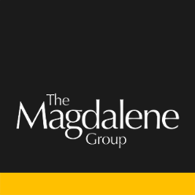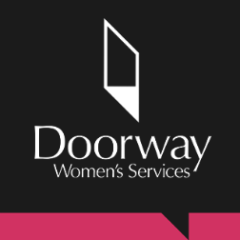

Women’s Specialist Practitioner
Person Specification

Criteria | Must be able to demonstrate
Skills and Knowledge
- Excellent inter-personal skills with the ability to establish and maintain positive relationships with marginalised women.
- Empathy with and understanding of the needs of stigmatised and marginalised women and the challenges and barriers they face.
- An in-depth understanding of the specific needs of women experiencing exploitation and multiple disadvantage.
- Specialist knowledge of housing would be an advantage.
- An understanding of the impact of trauma and of working within a trauma- informed approach with women in this context.
- Knowledge and understanding of current legislation related to safeguarding.
- Ability to work with high-risk presentations and complexity while remaining effective.
- Ability to work autonomously and as part of a team.
- Ability to organise and manage a high workload and to work with case-management procedures.
- Experience of working in partnership with a wide range of agencies both statutory and voluntary.
- Ability to work with volunteers in the delivery of the project.
- Ability to produce reports for trustees, funders and management.
- Ability to communicate effectively to a range of stakeholders.
- Strong administration, IT and digital media skills including Microsoft Word, Excel and Outlook.

Education, Experience and Achievements
- A degree in a relevant field or demonstrable experience of working with sex workers and/or women who have experienced exploitation and coercion.
- Demonstrable experience of providing crisis-support, managing risk and providing interventions.
- Experience of identifying and carrying out risk and needs assessments.
- Experience of working with vulnerable women in a range of settings and providing assertive outreach.
- Experience of providing support and advocacy while ensuring choice, collaboration transparency and safety.
- Ability to identify safeguarding concerns and take appropriate action to ensure children and vulnerable adults are protected.
- Experience of partnership/ multi-agency working.
- Experience of contributing in multi-disciplinary meetings.
- Confidence or experience working with digital media technology.
Personal Attributes
- Ability to establish and maintain clear boundaries in respect of personal and professional responsibility.
- Confident, adaptable and flexible approach.
- High level of accuracy, attention to detail and able to maintain records throughout all services.
- Commitment to equality and diversity throughout all service delivery.
- Passionate about working with and listening to women.
Special Circumstances
 | - An interest in the ongoing development of The Magdalene Group.

